Assignment No. 5

* Create Sales table with the following fields( Sales No, Salesname, Branch, Salesamount, DOB)

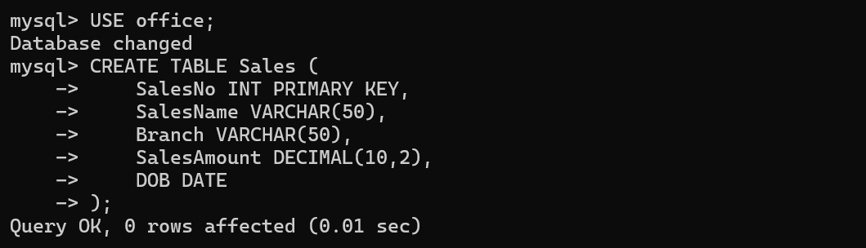

1. Insert five records.

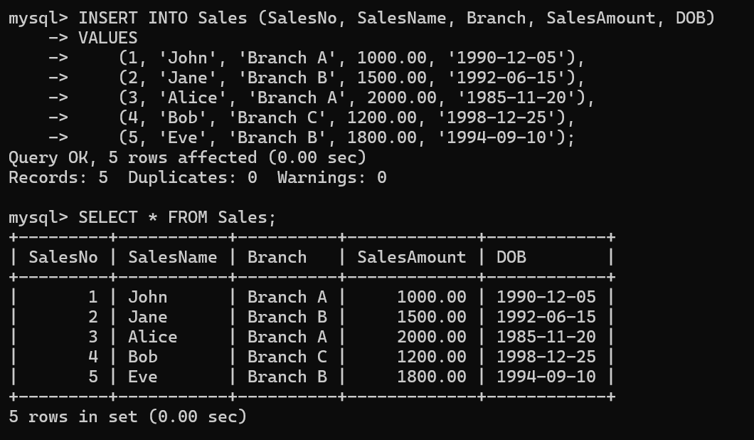

1. Calculate total sales amount in each branch.

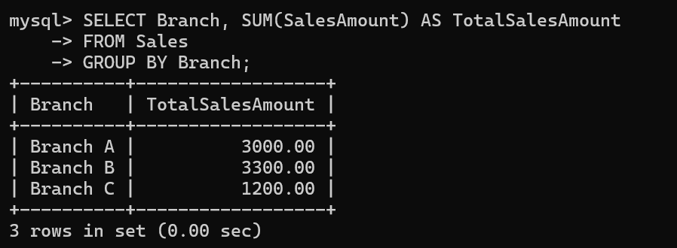

1. Calculate average sales amount in each branch .

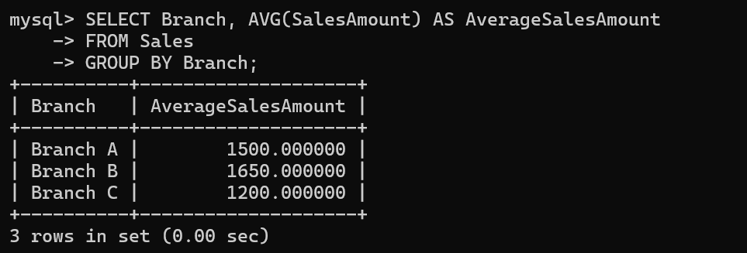

1. Display all the salesmen, DOB who are born in the month of December as day in character format i.e. 21-Dec-09.

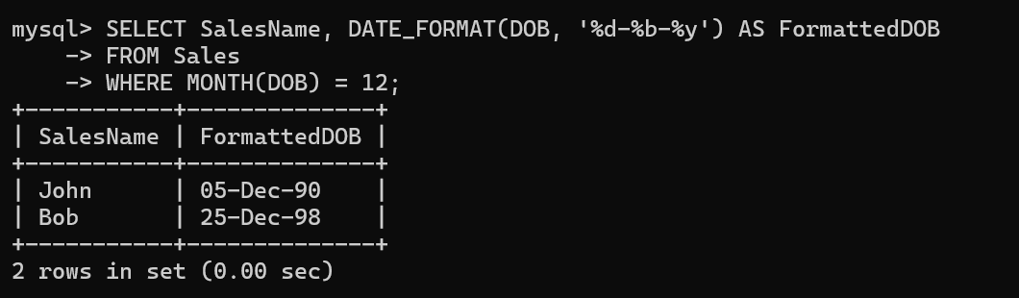

1. Display the name and DOB of salesman in alphabetical order of the month.

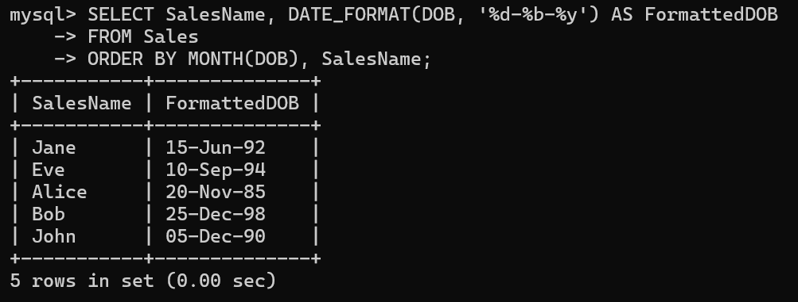

1. Display the list of the Salesman in Upper Case.

